EXPERIMENT-12
Aim: Connecting application with database. Establish a connection between your android application and the SQLite database. Test the connection by inserting and retrieving data.

Theory:
In Android applications, SQLite is commonly used as a lightweight, embedded database to store and manage structured data locally on the device. Establishing a connection between the application and SQLite involves creating a helper class (usually by extending SQLiteOpenHelper) that manages database creation and version control. Through this connection, the application can perform operations such as inserting, updating, deleting, and retrieving data using SQL queries. Data insertion is typically done using methods like insert() with ContentValues, while retrieval is performed using query() or raw SQL queries, returning results in a cursor object. Testing the connection ensures that the database is correctly initialized and that data can be successfully stored and accessed, confirming proper integration between the Android application and the SQLite database.

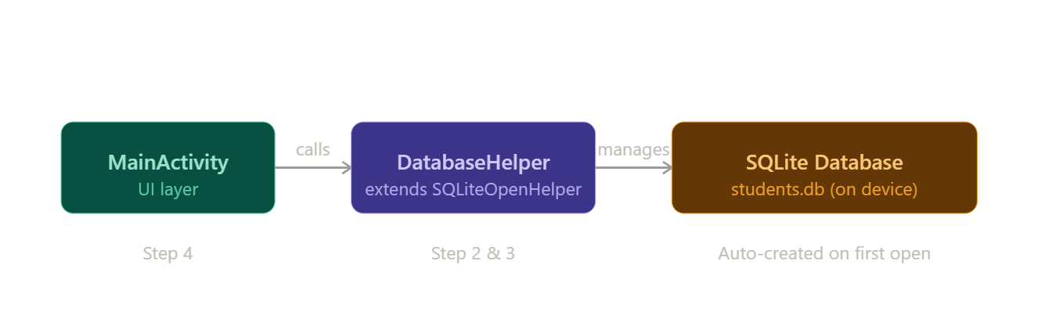
Step 1: Create Android Project
- Open Android Studio
- Click New Project
- Select Empty Views Activity
- Choose language: Java
- Finish setup
Step 2: Understand SQLite in Android
- SQLite is inbuilt in Android
- No need to install database separately
- Data is stored locally in the device
Step 3: Create Database Helper Class
- Create a class:
👉 DBHelper.java
Step 4: Add Insert Method
public boolean insertData(String name)
Step 5: Add Retrieve Method
public Cursor getData()
Step 6: Design UI (activity_main.xml)
Step 7: Connect UI with Database (MainActivity.java)

Code:
DBHelper.java
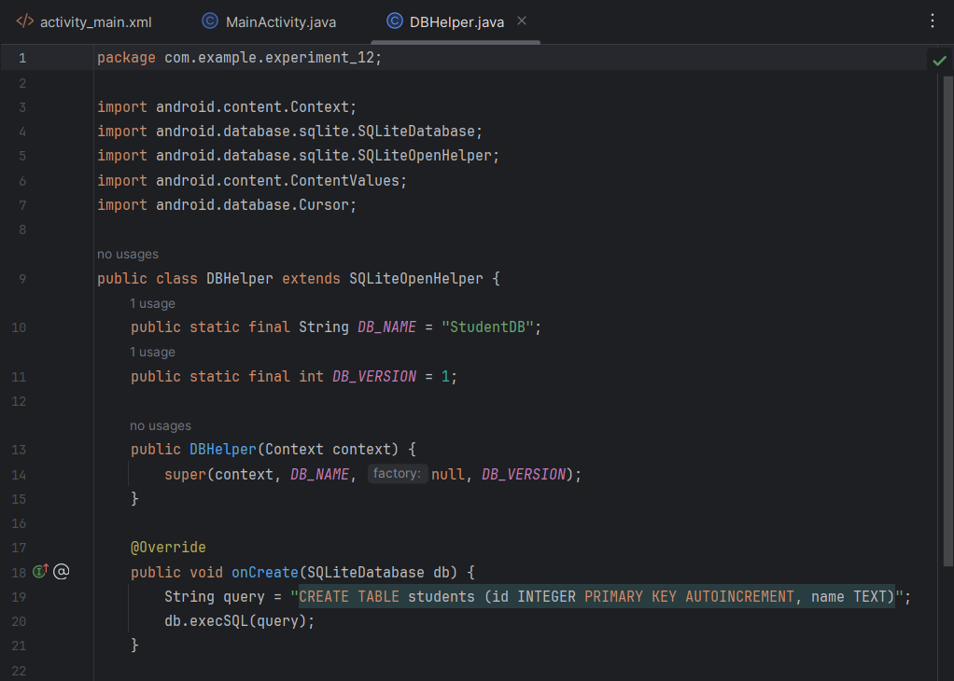
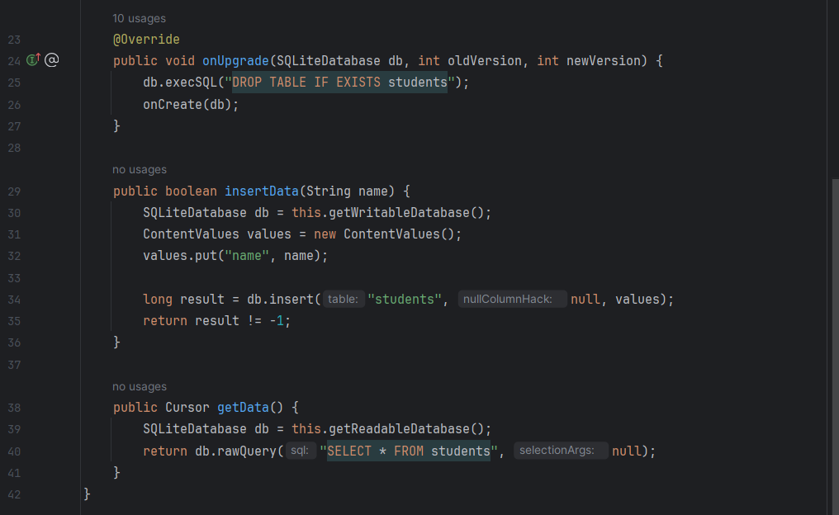

activity_main.xml
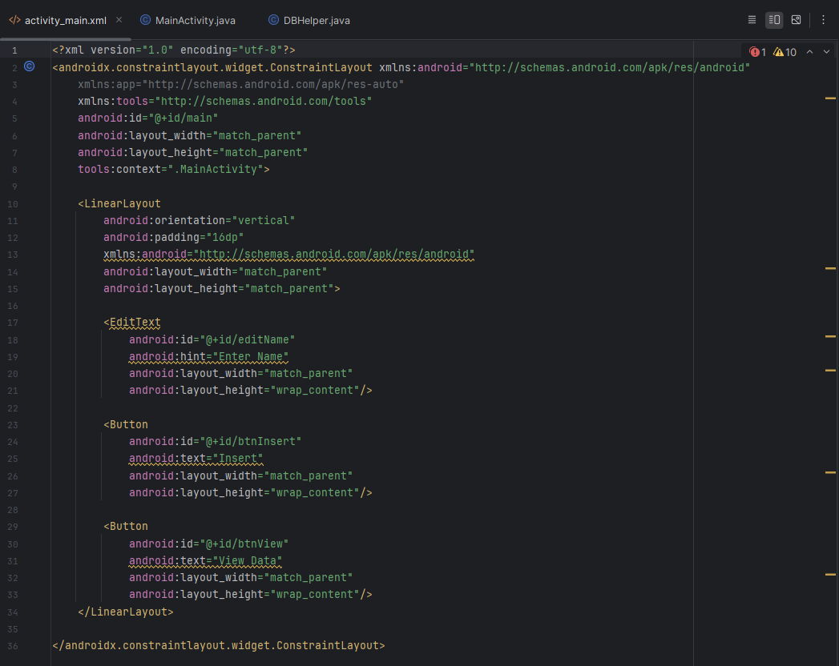

MainActivity.java
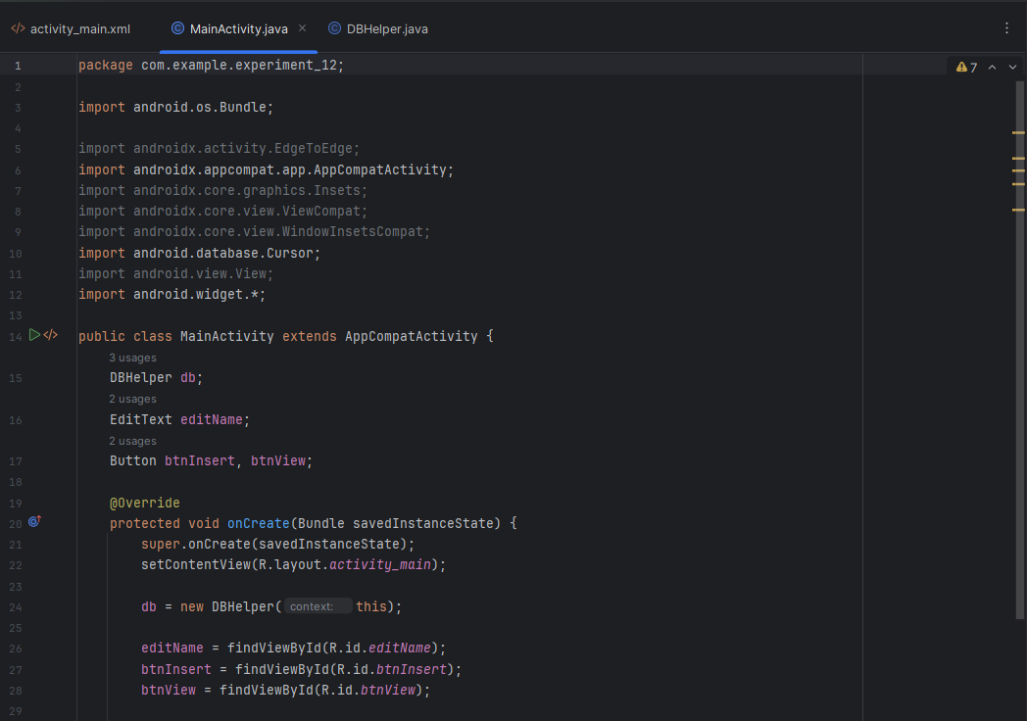
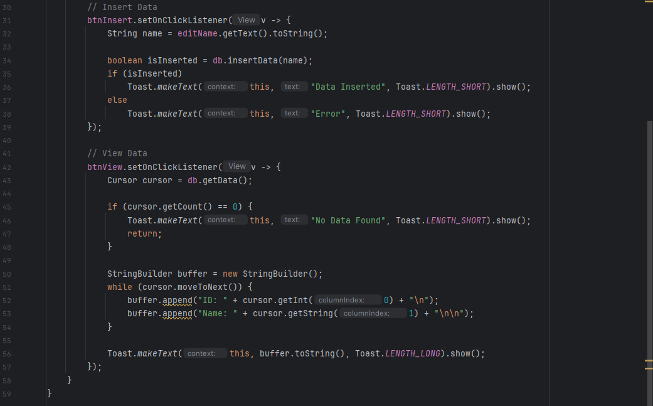

Output:

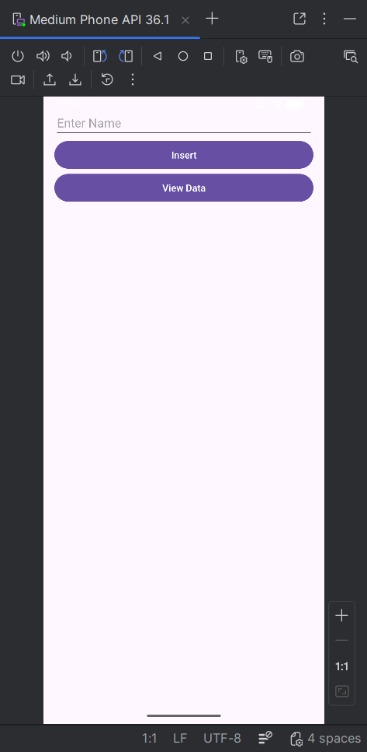 | 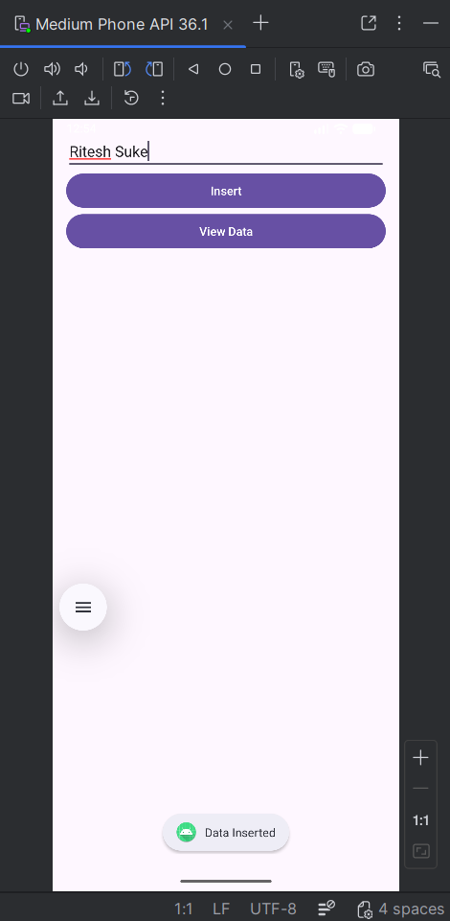 | 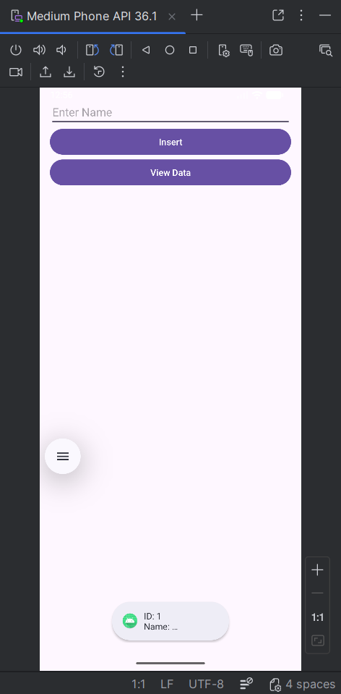

Conclusion:
Integrating an Android application with SQLite ensures efficient and reliable local data storage and management. By establishing a proper connection using SQLiteOpenHelper, developers can seamlessly perform database operations such as insertion and retrieval. Successful testing of these operations confirms that the application interacts correctly with the database, enhancing data persistence and overall app functionality. This integration plays a crucial role in building responsive and data-driven Android applications.

